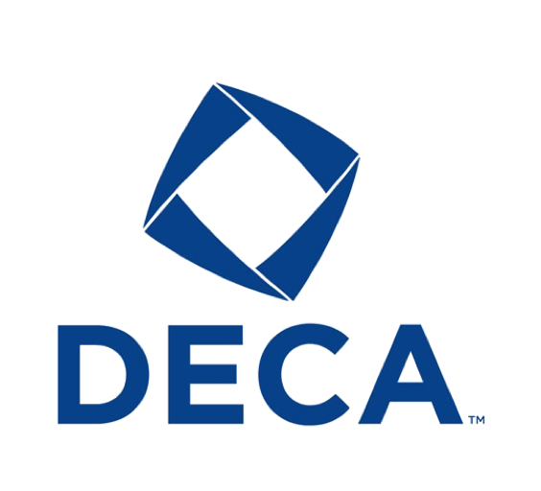[](http://webfc.rockingham.k12.va.us/LoginA89CD4122EC19B2F/FAV2-00107984/I00911C96.1/1292008_94205_0.gif?src=.BMP)Turner Ashby DECA Champions

*State Champions*

|  |  |  |  |
| --- | --- | --- | --- |
| Year | Place | Event | Participants |
| 2004 | Top 10 Finalist | Marketing Management | Curtis Anderson |
| 2006 | Top 10 Role Play | Full Service Restaurant Management | Rebekah Blackwell |
| 2006 | 1st Place | Business Law & Ethics Team Decision Making | AJ Smith & Brittany Miller |
| 2006 | Top 6 Finalists | Entrepreneurship Written Event | Alli Bland, Elizabeth Fleishman, & Rachel Swecker |
| 2007 | Top 6 Finalists | Retail Marketing Research | Katie Baugher, Morgan Brown, & Kyla Little |
| 2007 | Top 10 Finalists | Retail Marketing Research | Michelle Kosco & Ashely Chapman |
| 2007 | Top 10 Finalists | Advertising Campaign | Heather Simmons & Julia Scordo |
| 2008 | 1st Place | Retail Marketing Research | Hallie Brunton & Brittany Knight |
| 2008 | Top 6 Finalist | Community Service | Michelle Kosco |
| 2008 | Top 6 Finalists | Learn & Earn Project | Katie Baugher & Morgan Brown |
| 2008 | Top 6 Finalists | Public Relations Project | Craig Burkholder & Kyla Little |
| 2009 | Top 10 Finalists | Financial Literacy Project | Hallie Brunton & Kacey Miller |
| 2009 | Top 8 Finalist | Apparel & Accessories Marketing | Paloma Rodrigo |
| 2009 | Top 8 Finalist | Retail Merchandising Series | Sarah Fulk |
| 2013 | Top 8 Finalist | Community Service Project | Jennifer Bayes, Kasey Linn, & Rebekah Roach |
| 2014 | 1st Place | Learn and Earn Project | Kori Atkins, Matthew Overacker, & Jake Roth |

*National Competitors*

|  |  |  |
| --- | --- | --- |
| Year | Event | Participants |
| 2006 | Business Law & Ethics Team Decision Making | AJ Smith & Brittany Miller |
| 2006 | Entrepreneurship Written Event | Alli Bland, Elizabeth Fleishman, & Rachel Swecker |
| 2007 | Retail Marketing Research | Katie Baugher, Morgan Brown, & Kyla Little |
| 2008 | Retail Marketing Research | Hallie Brunton & Brittany Knight |
| 2008 | Community Service | Michelle Kosco |
| 2008 | Learn & Earn Project | Katie Baugher & Morgan Brown |
| 2008 | Public Relations Project | Craig Burkholder & Kyla Little |
| 2009 | Financial Literacy Project | Hallie Brunton & Kacey Miller |
| 2009 | Apparel & Accessories Marketing | Paloma Rodrigo |
| 2009 | Retail Merchandising Series | Sarah Fulk |
| 2013 | Community Service Project | Jennifer Bayes, Kasey Linn, & Rebekah Roach |
| 2014 | Learn and Earn Project | Kori Atkins, Matthew Overacker, & Jake Roth |

*National Champions*

|  |  |  |  |
| --- | --- | --- | --- |
| Year | Place | Event | Participants |
| 2008 | 7th place | Learn & Earn Project | Katie Baugher & Morgan Brown |

*Chapter Awards*

|  |  |  |  |
| --- | --- | --- | --- |
| Year | Place | Event | Participants |
| 2006 | 3rd | Salvation Army Bell Ringing - $408.88 raised | TAHS DECA Chapter |
| 2008 | 1st place | Highest Percent Growth Chapter With One Advisor | TAHS DECA Chapter |
| 2009 | 3rd Place | Community Service Award | TAHS DECA Chapter |
| 2009 |  | 1 or 7 Schools to participate in Y-Street Grant | TAHS DECA Chapter |
| 2009 |  | Recognition for Participation In Virginia DECA Day | TAHS DECA Chapter |
| 2009 |  | District President | Clark Adams |
| 2009 |  | District Advisor | Melissa Talley |
| 2009 |  | Catalyst Award | Melissa Talley |
| 2009 |  | Preferred Chapter Trophy Award for Annual Report | TAHS DECA Chapter |
| 2009 |  | SuperStar Chapter Recognition | TAHS DECA Chapter |
| 2011 |  | Platinum Level Membership Award | TAHS DECA Chapter |
| 2011 | 1st place | Largest Chapter Donation to a Charity | TAHS DECA Chapter |
| 2011 | 1st place | Largest Donation Per Member to a Charity | TAHS DECA Chapter |
| 2013 |  | Superstar Chapter | TAHS DECA Chapter |
| 2014 |  | Superstar Chapter | TAHS DECA Chapter |
|  |  |  |  |